**Creating Student AWS Educate and AWS Starter Accounts**

AWS Educate is an educational division within Amazon Web Services (AWS) that works with High Schools and Colleges. AWS Educate is offering Columbus State students access to the AWS Educate website along with a 1-year AWS Starter account on the AWS Console that includes a $75 usage credit. The AWS Educate website provides extensive educational content on AWS usage and cloud concepts. The AWS Console provides access to the AWS system compute and storage facilities. The $75 AWS usage credit should be sufficient to cover the costs of the AWS usage during your Columbus State classes. Your Starter Account shuts off if you exceed $75 so that you can’t incur overage charges on the AWS system.

There is a two-step process to obtain AWS Educate access and the AWS Console Account (with $75 credit). This process will result in two accounts – one for AWS Educate and one for AWS Console. You first request your AWS Educate Account by following the instructions in Step 1 below. AWS Educate then approves your AWS Educate Account, establishes an AWS Console Account in your name, and sends you an email to your Columbus State (CSCC) student email address. The email explains your new accounts and details how to login to AWS Educate. You then login to AWS Educate to complete the instructions in Step 2 below which will activate your new AWS Console Account for 1 year.

So, go ahead and **do Step 1; but then wait for an email** from AWS Educate before proceeding to Step 2. Once you’ve completed Step 2, you will have access to the AWS Console.

**Step 1: Request your AWS Educate Account.**

The instructions below detail the step 1 creation of an AWS Educate account.   After you request your AWS Educate account there will be a delay of minutes to hours while AWS Educate reviews and approves your request.  You will receive an email from AWS Educate with instructions on how to access and login to AWS Educate.  It may take some time for AWS Educate to create your account credentials and prep your AWS Console for you.  Don't repeat the setup process. The welcome email from AWS Educate explains your new accounts and details how to login to AWS Educate.

**Tips:**

* **Do not go directly to the AWS Educate website** to request your account. You must start Step 1 with the link in the blackboard ‘AWS’ Folder. If not, you won’t receive your AWS Console Starter Account with $75 usage credit.
* You will not have instant access to your new AWS Educate account; the process can take from minutes to hours. **Please do not run the Step 1 process from blackboard a second time**.
* Wait until you receive a welcome email from AWS Educate, after completing step 1, before trying to complete step 2.

**Follow these instructions to create a new AWS Starter Account for your student use.**

1. Log into blackboard with your student ID
2. Select your course to view the course menu
3. Select the ‘AWS’ folder from the course menu
4. Select ‘Create AWS Student Starter Account’ from the AWS Menu which displays the screen shown below.
5. Select ‘Launch’ (see screenshot below). You will be redirected out to the AWS Educate application process. This integration launch passes information to the AWS Educate application process that automates the approval process for your account request. So, don’t go directly to the AWS Educate website to apply or this cool process doesn’t work.

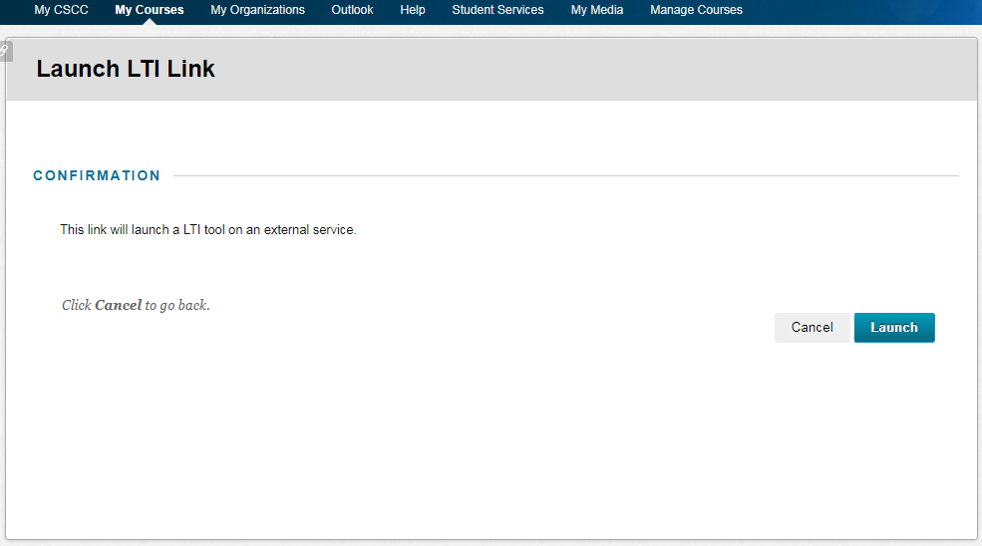

1. When the ‘AWS Educate’ application screen shown below is displayed, fill-in your Name, Address & student email address at the top of the screen. Select "Computer Science" for the field of study. (see screenshot below). **NOTE THAT YOU MUST USE YOUR CSCC STUDENT EMAIL ADDRESS** (such as ‘[youxxxx@student.cscc.edu](mailto:you@student.cscc.edu)’) in order to receive the $75 student usage credit from AWS. Proceed to step 7, below, for instructions about the selections at the bottom of the screen, below email.

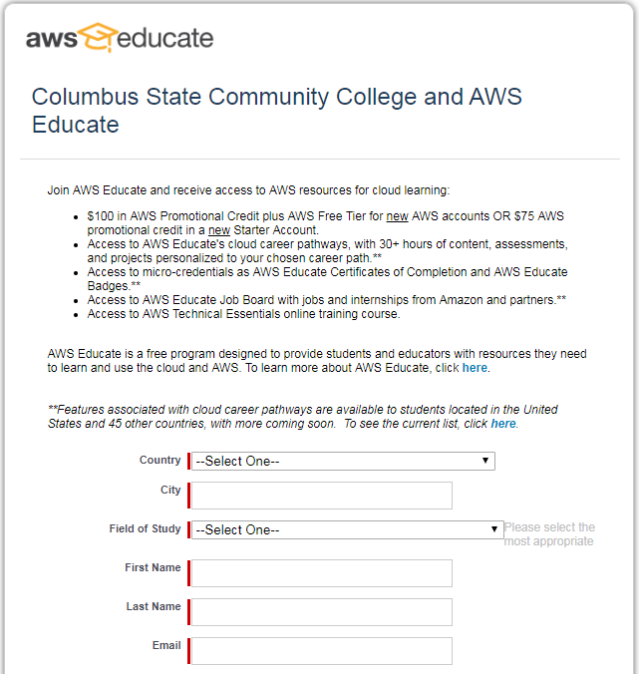

1. Continue on the bottom of the ‘AWS Educate’ screen. Make the following selections, as shown on the below screenshot:
   1. Select AWS Educate Starter Account -> ‘Click here to select an AWS Educate Starter Account’
   2. Completion year for current course: select year
   3. Completion month for current course: select month
   4. Continue to step 8 below for instructions on the ‘I’m not a robot’ selection at the bottom of the screen.

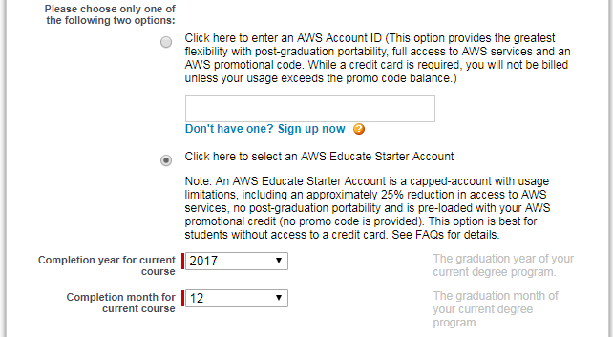

1. Continue on the bottom of the ‘AWS Educate’ screen. Select ‘I’m not a robot’. You may see a screen with pictures. Follow the on-screen directions on that screen and then click ‘VERIFY’ (see screenshot below). Click the gold ‘Next’ button to proceed to the next screen. Proceed to step 9 below.

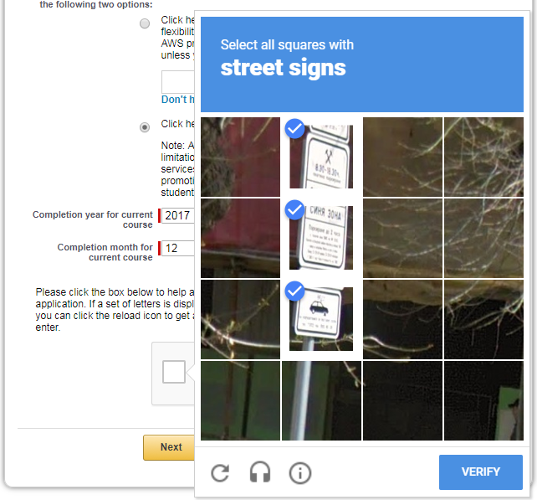

1. AWS Educate Student Site Terms and Conditions Screen. Read the terms & conditions. If you agree, click ‘Accept the terms’ at the very bottom of the screen (see screenshot below). Then click the gold ‘Submit’ button to proceed to the next screen.

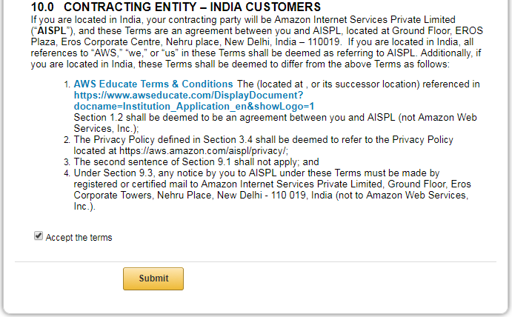

1. After you click on ‘Submit’ to accept the terms, you’ll see the screen below re: ‘Thanks, we received your request to join AWS Educate’. Ignore the invitation to join AWS Educate in this email and ignore the ‘click here’. You just sent them a request to join so this is redundant. 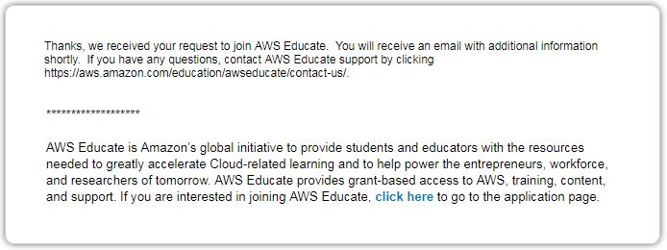
2. You will receive a welcome email from AWS Educate as a result of the above process**. It will take minutes to hours for you to receive this welcome email** – you must wait for it to arrive before proceeding though. Here is an example of the welcome email that you will receive:

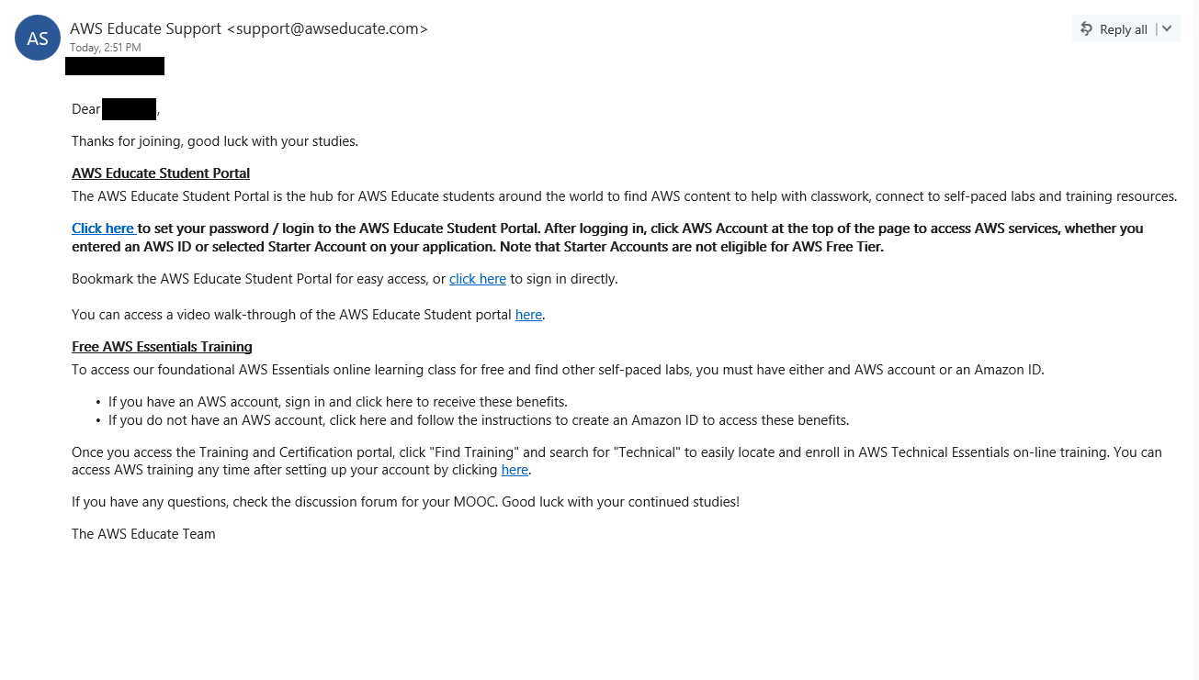

1. Click on the first ‘Click here’ link in the welcome email to create a new password for your new AWSEducate account. Enter a new password in the screen shown below. Press ‘Set Password’.

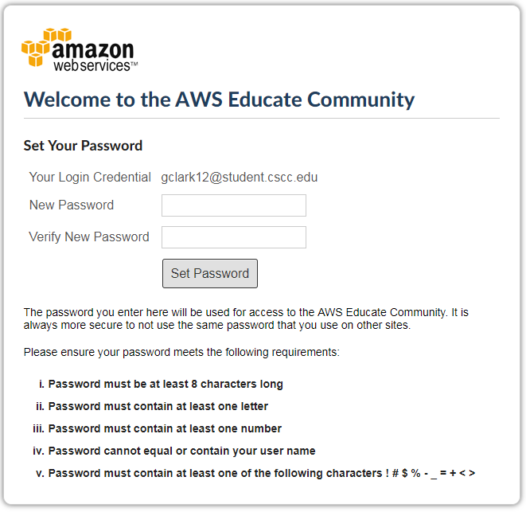

1. The AWSEducate Portal is located at <https://www.awseducate.com/SiteLogin> You can now use your AWS Student account and new password to login to the AWS Educate website. You can also proceed to Step 2 to activate your AWS Console Student Starter account and $75 usage credit. Proceed to Step 2 below.

**Step 2: Activate your AWS Console Starter Account and $75 usage credit**

When AWS Educate approved your request for a student account, they also created a new AWS Console Starter Account in your name. But that new account is not activated until you use it for the first time. The instructions below explain how to activate your AWS Console Starter account and start your 1 year AWS Console access and $75 student usage credit.

You will then be able to access your AWS Console by going to AWS Educate, My Account.  Do not try to select the big orange Console button in other AWS websites.  That is for those who have non-Starter AWS accounts.  Your Starter AWS Console access is only available in one manner – explained below.

1. Go to www.awseducate.com

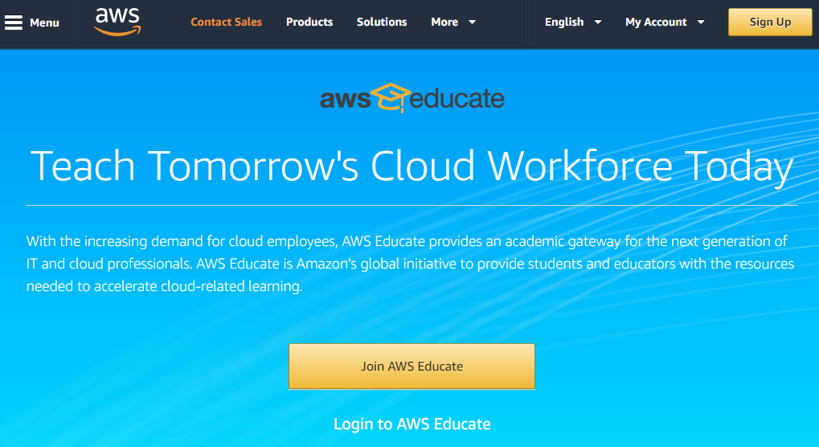



1. Click on ‘Login to AWS Educate’, circled in red on the screenshot above.
2. Login to AWS Educate with your new account credentials.

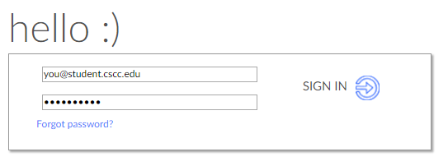

1. Click on ‘AWS Account’ in the top banner of the AWS Educate home page that will be displayed after you’ve signed-in. (circled in red in the screenshot below).

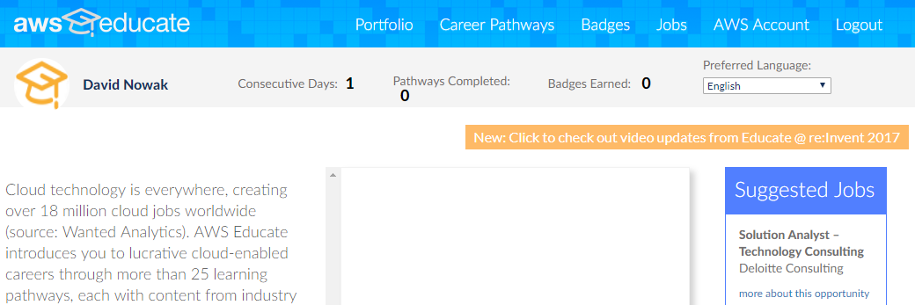



1. The ‘AWS Account’ screen provides access to your AWS Starter Account. Click on the ‘Go to your AWS Educate Starter Account’ button (circled in red on the screenshot below). You will always access your AWS Console in this manner. Don’t click on other AWS Console buttons throughout the AWS websites because those don’t provide access for AWS Starter Accounts. This is the one way for you to access the AWS Console with your Starter account.

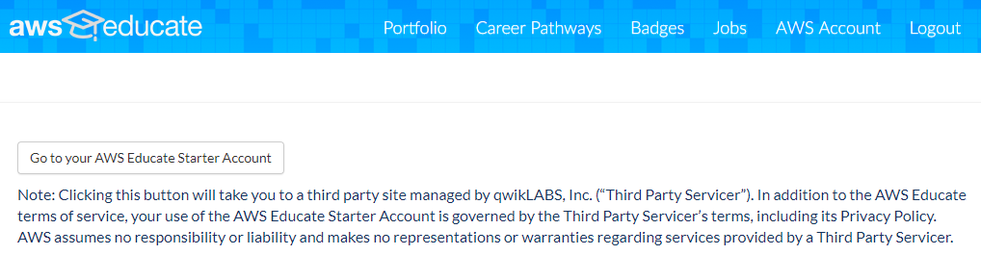



1. Activate your AWS Starter Account. You will see the screen below just once – to activate your Starter account and start your 1 year AWS Console access and $75 usage credit. Click on the big green ‘**Start Lab’** button.

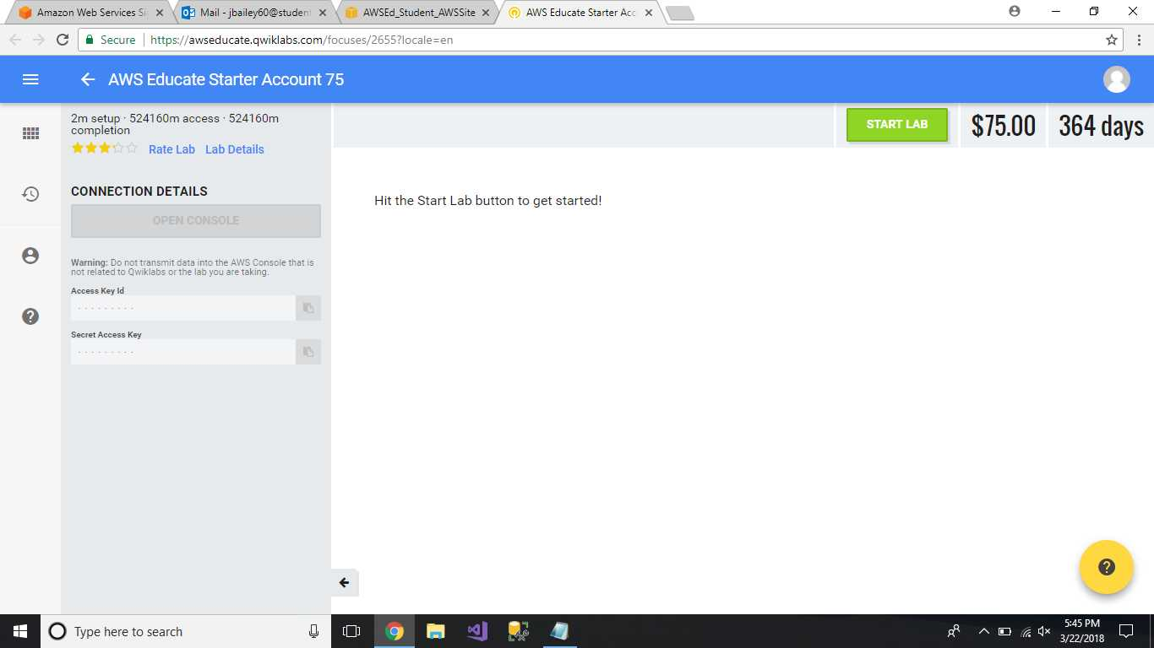



1. After you have activated your lab for the first time, you will access your AWS Starter Account by clicking on the big yellow ‘**Open Console’** button (ignore the ‘Hit the Start Lab button to get started’). Do **not** click on ‘End Lab’ at the end of your session – the ‘End Lab’ button permanently terminates your Starter Account! Big Oooops!

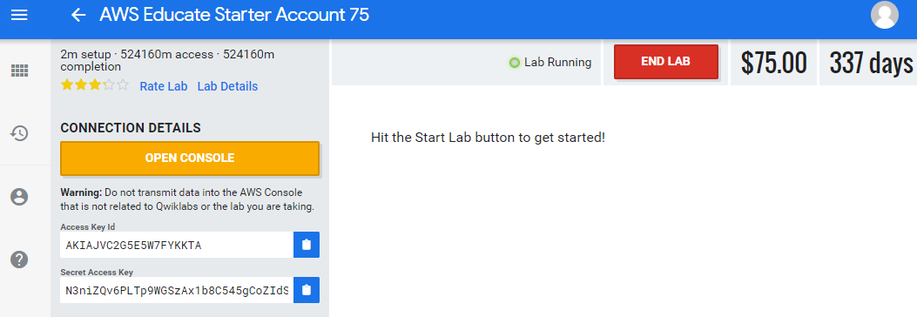



1. AWS Console – the below screenshot shows your AWS Console once you’ve clicked on ‘Open Console’. To log out of your AWS Console, click on the ‘down arrow’ (circled in red in the screenshot below) and select ‘Logoff’ from the drop down menu. **Again, don’t click on the red ‘End Lab’ button**.

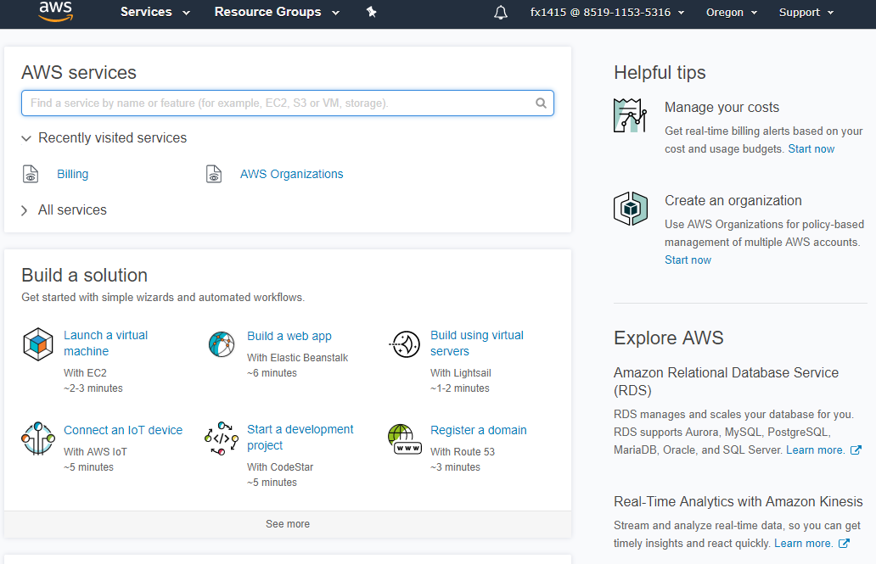



**You will access your AWS Starter account each time by following 1 through 5 +7 above.**